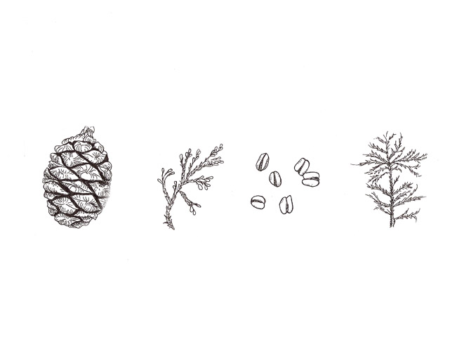

| **ITEM #** | **ITEM** | **QUANTITY** | **COST** | **TOTAL** |
| --- | --- | --- | --- | --- |
|  |  |  |  |  |
|  |  |  |  |  |
|  |  |  |  |  |
|  |  |  |  |  |
|  |  |  |  |  |
|  |  |  |  |  |
|  |  |  |  |  |
|  |  |  |  |  |
|  |  |  |  |  |
|  |  |  |  |  |

|  |  |  |
| --- | --- | --- |
| **SUB-TOTAL** |  | $ |
| **CALIFORNIA SALES TAX** | **0.09%** | $ |
| **SHIPPING HANDLING** | **See chart on ‘How to Order’ page.** | $ |
| **TOTAL** |  | **$** |

BILLING ADDRESS:

Name: _________________________

Address:_______________________

_______________________________

_______________________________

Phone:_________________________

Email:__________________________

SHIPPING ADDRESS:

Name: _________________________

Address:_______________________

_______________________________

_______________________________

Phone:_________________________

Email:__________________________

**Sierra Nature Prints**

P.O. Box 66644

Scotts Valley, CA 95067

831-335-4800

[pegedwards@sierranatureprints.com](mailto:pegedwards@sierranatureprints.com)

[www.sierranatureprints.com](http://www.sierranatureprints.com)

Make checks payable to **Sierra Nature Prints**

Gift card message: _________________________________

_________________________________________________